PAWSCARE
Submitted by
PRANAV MOHAN (Reg.no: 32022895016)
Under the supervision of
JOLLY SUBASH
(Assistant Professor, Department of Computer Science)
COLLEGE OF APPLIED SCIENCE PERISSERY



PROJECT REPORT
Submitted in partial fulfilment of the requirements for the award of
B.Sc. (Computer science) degree of
University of Kerala

2024
COLLEGE OF APPLIED SCIENCE
PERISSERY
DEPARTMENT OF COMPUTER SCIENCE
Certificate
Certificate that this report titled PAWSCARE is a bonafide record of the project work done by PRANAV MOHAN (Reg,no: 32022895016) under of our supervision and guidance, towards partial fulfilment of the requirements for the award of the degree of B.Sc. (Computer Science) of the University of Kerala.

Project Guide Head of Department principal

JOLLY SUBASH SINDHU R NAIR Dr.SREEKUMAR
Asst. Professor Asst. Professor
Dept. Of CS Dept. of CS

External Examiner

ACKNOWLEDGEMENT

First and foremost, we would like to acknowledge the Almighty God for the successful completion of our project.
We are very thankful to our guide, Jolly Subash, for providing her invaluable guidance, comments and suggestions throughout this project work. We would specially thank our Head of Department, Sindhu R Nair, for constantly mentored us.
We wish to record sincere thanks to all our family members who blessings made this task possible.

PRANAV MOHAN

- INTRODUCTION

  - OVERVIEW

The ultimate aim of developing the website “PAWSCARE” is to managing the overall vaccination of dogs. In a world where our pets are cherished family members, ensuring their well-being is paramount. PawsCare is a cutting-edge web platform designed to streamline anti-rabies vaccination management for dogs. By automating reminders and facilitating communication between pet owners and veterinary professionals. PawsCare aims to create healthier, happier canine companions. Join us on this digital journey toward responsible pet care.

1.2. PROBLEM DEFENITION

System analysis is the process of gathering data and facts diagnosing problem to the system. In the development of software structural analysis is required. During this analysis, information is collected in the form of answers to the question for collecting information from existing documents. Analysis specifies what the system should do.

Problem definition deals with defining the actual problem involved in the existing system or the system to be developed. Studies on various areas covered by the existing system are classified into various divisions and the actual task to be performed in the new system is determined. The project will be able to demonstrate the ideas of a website which helps the public. The website is trying to revitalize and simplify the various functions and activities and make them more people friendly. We dedicated to providing better speedy services to the public.

System analysis is the detailed study of various operations and their relationship within and outside the system. It is the first in the developing and managing systems. System analysis is concerned with becoming aware of the problem, identifying the relevant and most decisional variables, analysing and synthesizing the various factors and determining an optimal or at least as at is factory solution on programme of action. A preliminary study was conducted in details several fact-finding techniques like record searching, observation, comparison etc. were used to reach a better decision. The current system for this each activity was deeply studied and analysed. All the forms and other printed or non-printed formats for data collection where checked accurately and findings were compared. Observation was done to graet extend to see the difficulties of the process and time delay in finding the results. Accurate study was conducted to know the system in a much better manner.

1.3. OBJECTIVE

The objectives of the system analysis are:
- Identifying he need.
- Analysing the existing and proposed system
- Evaluating the feasibility study.
- Perform economic and technical analysis.
- Identifying the hardware and software requirements.
- Allocating functions to the hardware and software.

The three distant user’s roles

1.User
- User can register, book appointments.
- One user can register vaccination for multiple dogs.
- User can view the appointments that are granted by the hospital.
- User can request the hospital to reschedule the appointments.
- User can receive the notifications and alerts send by the hospital.

2. Admin
. DBA have the responsibilities including:
    - Managing the database
    - Securing the database
    - Maintaining the database
- They authorize handle capacity planning installation and monitor usage.
- Admin can view complaints made by the user.

- Hospital

- Hospital can access full details of the dogs.
- Hospital can view their own profile and can update it.
- They can send real-time alerts and notifications via sms, email, and through the website.
- They can provide appointments to the users and view those appointments in the website.
- They can reschedule the appointments as per the needs of the user.

- 2.SYSTEM STUDY

2.1. INTRODUCTION

In a world where our pets are cherished family members, ensuring their well-being is paramount. PawsCare is a cutting-edge web platform designed to streamline anti-rabies vaccination management for dogs. By automating reminders and facilitating communication between pet owners and veterinary professionals. PawsCare aims to create healthier, happier canine companions.

2.2 EXISTING SYSTEM

In the realm of innovative solutions, PawsCare stands out—a visionary platform that seamlessly manages anti-rabies vaccinations for our beloved dogs. Picture a world where pet owners receive personalized reminders via text messages and email, ensuring timely vaccinations. Imagine veterinary professionals effortlessly accessing appointment details and sending notifications.

2.2.1. Drawbacks

. The main drawback of the existing system is that the documentation barriers.
. There is a rush in the veterinary hospital and due to which there is loss of time.

2.3. PROPOSED SYSTEM

The proposed system “Paws Care” or PAWS CARE overcomes all the disadvantages of existing system by adding extra features. It is a visionary platform that simplifies canine anti-rabies vaccination management. Pet owners register their dogs, record vaccination dates, and receive automated reminders via text and email. Veterinary hospitals view vaccination status, schedule appointments, and send personalized notifications. While Paws Care is yet to exist, its promise of healthier dogs is our mission.

2.3.1. Advantages

- Operations are done in systematic way.
- Avoid documentation difficulties & other constraints in hospitals.
- Organization can access the complete details of the pets.

2.4. MODULE DESCRIPTION

2. users

- User can register, book appointments.
- User can view the appointments that are granted by the hospital.
- One user can register vaccination for multiple dogs.
- User can request the hospital to reschedule the appointments.
- User can receive the notifications and alerts send by the hospital

2.Admin
. DBA have the responsibilities including:
    - Managing the database
    - Securing the database
    - Maintaining the database

- They authorize handle capacity planning installation and monitor usage.
- Admin can view complaints made by the user.

3.Hospital

- Hospital can access full details of the dogs.
- Hospital can view their own profile and can update it.
- They can send real-time alerts and notifications via SMS, email, and through the website.
- They can provide appointments to the users and view those appointments in the website.
- They can reschedule the appointments as per the needs of the user.

2.5. PROJECT PLAN

Planning is very important in every aspect of development work. Good managers carefully monitor developments at various phases. Improper planning leads to failure of the project. Software project plan can be viewed as the following:

- Within the organization: How the project is to be implemented? What are the various constraints? What is market strategy?

- With respect to the customer: Weekly or timely meetings with the customer with presentations on status reports. Customer feedback is also taken and further modifications and developments are done. Project milestones are deliverables are also presented to the customer.

For a successful project the following steps can be followed:

- Selection of project: Includes identifying project’s aims and objectives, understanding requirements and specification, methos of analysis, design and implementation, testing techniques and documentation.
- Project milestones are deliverables.
- Project estimates: including cost, time, size of code and duration
- Resource allocation: including hardware, software, previous relevant project information and digital library
- Risk management: including risk avoidance, risk detection, risk control and risk recovery
- Scheduling techniques: including work breakdown structure, activity graph, critical path method, Gantt chart and Program Evaluation Review Technique.
- People: including staff requirement, team management and customer interaction. Quality control and standard

  - FEASIBILITY STUDY

The initial investigation points to the question whether the project is feasible. The feasibility is conducted to identify the best system that meets all the requirements. This includes an identification description, an evaluation of proposed systems and the selection of the best system for the job. The requirements of the system are specified with a set of constraints such as system objectives and the description of the output. It is the duty of the analyst to evaluate the feasibility of the proposed system to generate the above results. Three key factors are to be considered during the feasibility study.

There are three aspects in the feasibility study portion of the preliminary investigation:

- Technical feasibility
- Economic Feasibility
- Operational feasibility

The proposed system "PAWSCARE" must be evaluated from the technical point of view first, and if technically feasible their impact on the organization must be assessed. If compatible, Technical Feasibility Economic Feasibility Operational system can be devised. Then they must be tested for economic feasibility.

2.6.1. Technical Feasibility

The "PAWSCARE" must be evaluated from the technical viewpoint. The assessment feasibility must be based on an outline design of the system requirement in the terms of input, output, programs, procedure and employee. Having identified an outline system, the investigation must go to suggest the type of the equipment, required method developing the system, method of running the system once it has been designed. The project should be developed such that the necessary functions and performance are achieved within the constraints. Though the system may become obsolete after some period of time, due to the fact that the newer version software supports the older version, this system may still be used.

There are a number of technical issues, which are generally raised during the feasibility stage of the investigation PAWSCARE. A study of function, performance and constraints that may affect the ability to achieve an acceptable system. Technical feasibility deals with hardware as well as software requirements. If the necessary requirements are made available with the system, then the proposed system is said to be technically feasible.

2.6.2. Economic Feasibility

Economic feasibility is an important task of system analysis. A system that can be developed technically and that will be used if installed must still be profitable for the organization. Financial benefits must equal or exceed the costs. Criteria are to ensure that effort taken on the project give the best return at the earliest. One of the factors, which affect the development of a new system, is the cost it would require. Since the system developed is part of a project work, there is no manual cost to spend for the "PAWSCARE". Also, all the resources are already available, giving an indication that the system is economically possible development. The analysis raises financial and economic questions during the preliminary investigation to estimate the following:

1. The cost to conduct a full systems investigation

2. The cost of hardware and software for the class of application of the project being considered.

3. The benefits in the form of reduced costs or fewer costly errors.

To be judged feasible, a proposal for the specific project must pass all these tests, otherwise it is not considered as a feasible project.

2.6.3. OPERATIONAL FEASIBILITY

Proposed projects are beneficial only if they can be turned into information systems that will meet the operating requirements of the organization. This test of feasibility tasks if the system will work when it is developed and installed. "PAWSCARE" satisfies all the operational conditions.

One of the main problems faced during development of a new system is getting the acceptance from the user. They were doubtful about the degree of security provided by our software. We have considered all the operational aspects. Thus, the project is operationally feasible. People are inherently resistant to change, and computers have been known to facilitate change. An estimate should be made about the reaction of the user, employee towards the development of a computerized system.

PYTHON
Python is a dynamic, high level, free open source and Interpreted programming language. It supports object-oriented programming as well as procedural oriented programming. In Python, we don't need to declare the type of variable because it is a dynamic typed language. For example, x=10, here x can be anything such as String, int etc.
PYTHON
Features
There are many features in Python, some of which are discussed below -
1. Easy to code:
Python is high level programming language. Python is very easy to learn language as compared to other language like c, c#, java script, java etc. It is very easy to code in python language and anybody can learn python basic in few hours or days. It is also developer friendly language.
2.Free and Open Source:

Python language is freely available at official website you can download it. Since, it is open source; this means that source code is also available to the public so you can download it as, used it well as share it.
3. Object-Oriented Language:
One of the key features of python is Object-Oriented programming. Python supports object-oriented language and concepts of classes, objects encapsulation etc.
4. GUI Programming Support:
Graphical Users interfaces can be made using a module such as PyQt5, PyQt4, python or Tk in python. PyQt5 is the most popular option for creating graphical apps with Python.
5. High-Level Language:
Python is a high-level language. When we write programs in python, we do not need to remember the system architecture, nor do we need to manage the memory.
6. Extensible feature:
Python is an Extensible language. We can write some python code into c or C++ language and also we can compile that code in C/C++ language.
7. Python is Portable language:
Python language is also a portable language. For example, if we have python code for windows and if we want to run this code on other platform such as Linux, UNIX and Mac then we do not need to change it, we can run this code on any platform.
8. Python is integrated language:
Python is also an integrated language because we can easily integrated python with other language like c, C++ etc.
9. Interpreted Language:
Python is an Interpreted Language. Because python code is executed line by line at a time. Like other language C, C++, java etc. there is no need to compile python code this makes it easier to debug our code. The source code of python is converted into an immediate form called byte code.
10. Large Standard Library:
Python has a large standard library which provides rich set of module and functions so you do not have to write your own code for every single thing. There are many libraries present in python for such as regular expressions, unit-testing, web browsers etc.
11. Dynamically Typed Language
Python is dynamically-typed language. That means the type (for example- int, double, long etc.) for a variable is decided at run time not in advance. Because of this feature we don't need to specify the type of variable.
Python is an interpreted language. This means that it is not converted to computer-readable code before the program is run but at runtime. In the past, this type of language was called a scripting language, intimating its use was for trivial tasks. However, programming languages such as Python have forced a change in that nomenclature. Increasingly, large applications are written almost exclusively in Python. Some ways that you can apply Python include:
Programming CGI for Web Applications
Building an RSS leader
Reading from and writing to MySQL
Reading from and writing to PostgreSQL
Creating Calendar in HTML
Working with Files
what can Python do?
Python can be used on a server to create web applications.
Python can be used alongside software to create workflows.
Python can connect to database systems. It can also read and modify files.
• Python can be used to handle big data and perform complex mathematics.
Python can be used for rapid prototyping, or for production-ready software development.
Why Python?
Python works on different platforms (Windows, Mac, Linux, Raspberry Pi, etc).
Python has a simple syntax similar to the English language.
Python has syntax that allows developers to write programs with fewer lines than some other programming languages.
The most recent major version of Python is Python 3, which we shall be using in this tutorial. However, Python 2, although not being updated with anything other than security updates, is still quite popular.
In this tutorial Python will be written in a text editor. It is possible to write Python in an Integrated Development Environment, such as Thonny, Pycharm, Netbeans or Eclipse which are particularly useful when managing larger collections of Python files.
Python Syntax compared to other programming languages
Python was designed for readability, and has some similarities to the English language with influence from mathematics.
Python uses new lines to complete a command, as opposed to other programming languages which often use semicolons or parentheses.
Python relies on indentation, using whitespace, to define scope; such as the scope of loops, functions and classes. Other programming languages often use curly-brackets for this purpose.
Django
Django is a web application framework written in Python programming language. It is based on MVT (Model View Template) design pattern. The Django is very demanding due to its rapid development feature. It takes less time to build application after collecting client requirement.
By using Django, we can build web applications in very less time. Django is designed in such a manner that it handles much of configure things automatically, so we can focus on application development only.
Django was design and developed by Lawrence journal world in 2003 and publicly released under BSD license in July 2005. Currently, DSF (Django Software Foundation) maintains its development and release cycle. Django was released on 21, July 2005. Its current stable version is 2.0.3 which was released on 6 March, 2018.
WSGI
Web Server Gateway Interface (WSGI) has been adopted as a standard for Python web application development. WSGI is a specification for a universal interface between the web server and the web applications.
Werkzeug
It is a WSGI toolkit, which implements requests, response objects, and other utility functions. This enables building a web framework on top of it. The Flask framework uses Werkzeug as one of its bases.
Jinja2
Jinja2 is a popular templating engine for Python. A web templating system combines a template with a certain data source to render dynamic web pages.
Flask
Flask is often referred to as a micro framework. It aims to keep the core of an application simple yet extensible. Flask does not have built-in abstraction layer for database handling, nor does it have form a validation support. Instead, Flask supports the extensions to add such functionality to the application. Some of the popular Flask extensions are discussed later in the tutorial.
JavaScript
Java script is a scripting language that can be used to create client-side scripts and server-side scripts. Client-side scripts are executed in the browser while server-side scripts are executed on a server. That is JavaScript is an object-based scripting language for developing client based and server-based internet applications. We can insert JavaScript statements directly into an HTML page. When the page is displayed in the browser, the JavaScript statements are interpreted and executed by the browser. JavaScript statements can recognize and respond to user events such as mouse clicks or system generated events and so on. So you can change the content and position of the elements on the page dynamically, in response to user interaction. When the client requests an HTML page that includes a client-side Script, the server forwards the full content of the HTML document- the JavaScript statements and the HTML content. When the browser receives the document, it executes the HTML and JavaScript statements without any interaction with the server while both client-side JavaScript and server-side JavaScript have the same core language; each also has additional features relevant to the environment. That is, client-side JavaScript includes predefined objects that can be used only in the browser. Server-side JavaScript contain predefined objects that can be used in server- side application.

HTML
An HTML file is a text file containing small markup tags. These tags tell the web browser how to display the page. An HTML file must have an htm or html file extension. An HTML file can be created by using a simple text editor. HTML documents are text files made up of HTML elements e.g.: <html>, <body>. HTML elements are defined using HTML tags. HTML tags are used to markup HTML elements. The two characters surround HTML tags <and>. The surrounding characters are called angle brackets. HTML tags normally come in pairs like <b> and </b>. The first tag in a pair is the start tag: the second tag is the end tag. The text between the start and the end tag is the element content. HTML tags are not case sensitive; <b> means the same as <B>.
- Cascading Style Sheets, fondly referred to as CSS, is a simple design language intended to simplify the process of making web pages presentable. CSS is a MUST for students and working professionals to become a great Software Engineer especially when they are working in Web Development Domain. I will list down some of the key advantages of learning CSS: Create Stunning Web site - CSS handles the look and feel part of a web page. Using CSS, you can control the color of the text, the style of fonts, the spacing between paragraphs, how columns are sized and laid out, what background images or colours are used, layout designs and variations in display for different devices and screen sizes as well as a variety of other effects. Become a web designer - If you want to start a career as a professional web designer, HTML and CSS designing is a must skill.
JavaScript is a dynamic computer programming language. It is lightweight and most commonly used as a part of web pages, whose implementations allow client-side script to interact with the user and make dynamic pages. It is an interpreted programming language with object-oriented capabilities JavaScript was first known as Live Script, but Netscape changed its name to JavaScript, possibly because of the excitement being generated by Java. JavaScript made its first appearance in Netscape 2.0 in 1995 with the name Live Script. The general-purpose core of the language has been embedded in Netscape, Internet Explorer, and other web browsers.
JavaScript is a lightweight, interpreted programming language.
Designed for creating network-centric applications.
Complementary to and integrated with Java
Complementary to and integrated with HTML
Open and cross-platform
Client-Side JavaScript
Client-side JavaScript is the most common form of the language. The script should be included in or referenced by an HTML document for the code to be interpreted by the browser. It means that a web page need not be a static HTML, but can include programs that interact with the user, control the browser, and dynamically create HTML content. The JavaScript client-side mechanism provides many advantages over traditional CGI server-side scripts. For example, you might use JavaScript to check if the user has entered a valid e-mail address in a form field. The JavaScript code is executed when the user submits the form, and only if all the entries are valid, they would be submitted to the Web Server. JavaScript can be used to trap user-initiated events such as button clicks, link navigation, and other actions that the user initiates explicitly or implicitly.
Advantages of JavaScript
the merits of using JavaScript are-
Less server interaction you can validate user input before sending the page off to the server. This saves server traffic, which means less load on your server.
Immediate feedback to the visitors they don't have to wait for a page reload to see if they have forgotten to enter something.

Microsoft Visual Studio Code
Visual Studio Code is a code editor in layman's terms. Visual Studio Code is "a free editor that helps the programmer write code, helps in debugging and corrects the code using the intelli-sense method". In normal terms, it facilitates users to write the code in an easy manner. Many people say that it is half of an IDE and an editor, but the decision is up to the coders. Any program/software that we see or use works on the code that runs in the background. Traditionally coding was used to do in the traditional editors or even in the basic editors like notepad! These editors used to provide basic support to the coders.
Some of them were so basic that it was very difficult in writing Basic English level programs in them. As time went by, some programming languages needed a specific framework and support for further coding and development it, which was not possible using these editors. VI Editor, Sublime Text Editor, is one of the many kinds of editors that came into existence. The most prominent and which supports almost every coding language is VISUAL STUDIO CODE. Its features let the user modify the editor as per the usage, which means the user is able to download the libraries from the internet and integrate it with the code as per his requirements.
Visual Studio Code has some very unique features. They are listed as below:
Support for multiple programming languages: Supports multiple programming languages. So earlier, programmers needed Web-Support: a different editor for different languages, but it has built-in multi-language support. This also means it easily detects if there's any fault or cross-language reference, it'll be able to detect it easily.
Intelli-Sense: It can detect if any snippet of code is left incomplete. Also, common variable syntaxes and variable declarations are made automatically. Ex: If a certain variable is being used in the program and the user has forgotten to declare, intelli-sense will declare it for the user.
- Cross-Platform Support: Traditionally, editors used to support either Windows or Linux or Mac Systems. But Visual Studio Code is cross-platform. So, it can work on all three platforms. Also, the code works on all three platforms; else, the open-source and proprietary software codes used to be different.
Extensions and Support: Usually supports all the programming languages but, if the user/programmer wants to use the programming language which is not supported then, he can download the extension and use it. And performance-wise, the extension doesn't slow down the editor as its rums as a different process.
Repository: With the ever-increasing demand for the code, secure and timely storage is equally important. It is connected with Git or can be connected with any other repository for pulling or saving the instances.

- Web-Support: Comes with built-in support for Web applications. So, web applications can be built and supported in VSC
Hierarchy Structure: The code files are located in files and folders. The required code files also have some files, which may be required for other complex projects. These files can be deleted as per convenience.
Improving Code: Some code snippets can be declared a bit differently, which might help the user in the code. This function prompts the user, wherever necessary, to change it to the suggested option.
Terminal Support: Many of the times, the user needs to start from the root of the directory to start with a particular action, in-built terminal or console provides user support to not to switch in-between two screens for the same.
- Multi-Projects: Multiple projects containing multiple files/folders can be opened simultaneously. These projects/folders might or might not be related to each other. Git Support: Resources can be pulled from Git Hub Repo online and vice-versa; saving can be done too. Resource pulling also means cloning the code which is made available on the internet. This code can later be changed and saved.
Another feature that naïve-users or anyone can see instantly different from other editors is the user-friendliness of the Visual Studio Code. The usability is very easy to handle. The file is arranged hierarchically and has regular software like a toolbar, status bar, and a sidebar. It also has a floating windows explorer window, which can be fixed at one place according to convenience, which consists of the directory structure of files. These files (code files, image folders, etc.) can be opened or renamed from here, and changes will automatically get reflected in the storage.

4.SOFTWARE DESIGN AND DEVELOPMENT
Design for Web Apps encompasses technical and non-technical activities that include establishing the look and feel of the Web App, creating the aesthetic layout of the user interface. defining the overall architectural structure, developing the content and functionality that reside within the architecture, and planning the navigation that occurs within the Web-app. Design allows you to create a model that can be assessed for quality and improved before content and code are generated, tests are conducted, and end users become involved in large numbers Design is the place where Web App quality is established.
In general, the following design objectives must be kept in mind,
Practicality of the System
Efficiency of the System
O Minimized cost of the System
Flexibility of the System
Security of the System
The system design involves first logical design and then physical construction of the system. The logical design describes structure and characteristics of features, like the outputs, inputs, databases and procedures. The physical construction which follows the logical design produces actual program software files and the working system.
System design sits at the technical kernel of the software engineering and is applied regardless of the software process model that is used. Beginning once software requirements have been analysed and specified, software design is the first technical activity that is used to build and verify the software. Each activity (designing, coding and testing) transforms information in a manner that ultimately results in validated computer software.
DATABASE DESIGN
The most important aspect of building an application is the design of database. The data they store must be organized according to the user requirement. A well-designed database is essential for the good performance of the system. A database table known as a relation provides information related to specific entity.
The basic functions involved in a database system related to the information required by the user are:
Defining the data
Input the data
locating the data.
Communicating the data

5. CODING AND TESTING

5.1 CODING STEPS
The coding step is a process that transforms design into a programming language. It translates a detail design representation of software into a programming language realization. The translation process continues when a compiler accepts source code as input and produces machine-dependent object code as output. Quality is an important goal during coding. The quality of source code can be improved by the use of structured coding techniques, good coding style and readable, consistent code format. During coding. Some coding standards are to be followed. This has two purposes; reducing the chance of making it easier for some time to modify the code later on. Coding phase affects both testing and maintenance profoundly.

The "PAWSCARE" uses Python as the programming language for coding. Python is an interpreted, interactive, object-oriented programming language. It incorporates modules, exceptions, dynamic typing. Very high-level dynamic data types, and classes. It supports multiple programming paradigms beyond object-oriented programming, such as procedural and functional programming Python combines remarkable power with very clear syntax. It has interfaces too many systems calls and libraries, as well as to various window systems, and is extensible in C or C++. It is also usable as an extension language for applications that need a programmable interface. Finally, Python is portable: it runs on many UNIX variants including Linux and macOS, and on Windows.
5.2. TEST PLANS
the purpose of system testing is to identify and correct errors in the candidate system. Testing is an important clement of the software quality assurance and represents the ultimate review of specification, design and coding. The increasing visibility of the software as a system element and the costs associated with a software failure are motivated forces for well planned, through testing.
The common view of testing held by users is that it is performed to prove that there are no errors in a program. However, as indicated earlier, this is virtually impossible, since analyst cannot prove that software is free and clear of errors. The tester, who may be the program fail. A successful test, then, is one that finds an error. Analysts know that an effective testing program does not guarantee system reliability. Therefore, reliability must be designed into the system.

Need of Testing
Testing is essential for:
▸ Existence of program defects of inadequacies is inferred.
▸ Verifies whether the software behaves as intended by its designer.
▸ Checks conformance with requirement specification/user needs.
▸ assesses the operational reliability of the system.
▸ Tests the performance of the system
▸ Reflect the frequency of actual user inputs.
▸ finds the fault, which caused the output anomaly.

Detects flaws and deficiencies in the requirements
Checks whether the software is operationally useful.
Exercises the program using data like the real data processed by the program.
The tan error is used to refer the difference between the actual output of the software and the correct output. Fault is a condition that causes the software to fail to perform its required function, Software reliability is defined as the required function
Software reliability is defined as the probability that the software will not undergo failure for a specified time under specified condition Failure is the inability of a system or a component to perform a required function according to its specification. Different levels of testing were employed for software to make an error free, fault free and reliable.
5.3. CLASSIFICATION OF TESTING
basically, in software testing four type of testing methods are adopted
5.3.1. Security Testing
Security testing is the process to determine that an information system protects data and maintain functionality as intended. During security testing, the tester plays roles of the individual who desires to penetrate the system. The tester may attempt to acquire passwords through external clerical means, may attack the system with custom software designed to breakdown any defences that have been constructed, may overwhelm the system, thereby denying service to others, may cause system errors, hoping to find the key to system entry. Digital Fortress was tested for successful acceptance. User can enter to the website without register.
5.3.2. User Interface testing
this tests the whole end to end scenario (which simulates exactly what the user would be doing). This (for the most part) goes through all the mouse clicks and keyboard presses the user goes through to get an action done. If we extend the previous example this would be invoking the same action except that this time instead of using any test hooks it would be using the keyboard.
5.3.3. Performance Testing
Performance testing is designed to test the run time performance of software within the context of an integrated system. Performance testing occurs throughout all steps in the testing process. Even at the unit level, performance of individual module may be assessed as white box tests are conducted, it is not until all system elements are fully integrated that true performance of a system can be ascertained. This system was tested for successful acceptance and was found to be working properly.
5.3.4. Test Cases
a test case is a document that describes an input, action or event and an expected response, to determine if a feature of an application is working correctly. A test case should contain particulars such as test case identifier, test case name, test conditions, input data requirements steps, and expected results

6. SYSTEM IMPLEMENTATION AND TESTING
6.1. IMPLEMENTATION OF THE PROJECT
Implementation means putting the newly developed system into operation. It is the plisse in the project plan where the theoretical design is put into real test. This is the most crucial stage in the life cycle of a project. During implementation there has to be a strong interaction between the developers and the users. This is the phase where the new system is given a chance to prove its worth and to minimize the reluctance to change. The proposed system may be entirely new, replacing an existing one or may be modifications to the existing system to either case, proper implementation is necessary to generate a Confidence among users. If the users have achieved satisfaction with the new project, then the project can be termed as successful and then onwards its maintenance and other subsequent works can be started. The system goes for implementation only after passing through some rigorous testing, especially when it comes to operating systems and other system software.
- The implementation phase of the software development is concerned with translating design specifications into source code. The user tests the developed system and changes are made according to their needs. Our system has been successfully implemented. Before implementation several tests to been conducted to ensure that no errors are encounter during the operation. The implementation phase ends with an evaluation of the system after placing it into operation for a period of time. Implementation is the third phase of the system process In order to achieve the objectives and the expected performance the system has been developed in a highly interactive and user-friendly manner.
The implementations stage involves following tasks:
• Careful planning.
• Investigation of system and constraints.
• Design of methods to achieves the changeover.
• Training of the staff in the changeover phase.
6.2 MAINTENANCE
Maintenance involves the software industry captive, typing up system resources. It means restoring something to its original condition. Maintenance involves a wide range of activities including correcting. Coding, and design errors, updating documentation and test data, and upgrading user support. Maintenance was done after the success implementation. Maintenance is continued till the product is reengineered or deployed to another platform. Maintenance is also done based on fixing the problems reported, changing the interface with other software or hardware enhancing the software.
A Post-Implementation is conducted after completing a project. Its purpose is to evaluate whether project objectives were met, to determine how effectively the project was run, to learn lessons for the future, and to ensure that the organization gets the greatest possible benefit from the project. After a long project, the last thing many project teams want to do is relive the process and look for ways to improve. However, a forward-looking review can discover many tips and strategies for improvement. By conducting a thorough and timely PIR, you'll identify key lessons learned and you can then apply those lessons to the planning and management of future projects.

7. FUTURE ENHANCEMENT

At this stage we can only opt or get service under a selected district and the hospitals residing in the particular local body. So, in future we can bring whole state under this service. In future we can add other animals such as in different categories also be allowed to be served here.

8. CONCLUSION
The old manual system was suffering from a series of drawbacks. Since whole of the system was to be maintained with hands the process of keeping, maintaining and retrieving the information was very tedious and lengthy. The records were never used to be in a systematic order. There used to be lots of difficulties in associating any particular transaction with a particular context. If any information was to be found it was required to go through the different registers, documents there would never exist anything like report generation. There would always be unnecessary consumption of time while entering records and retrieving records. One more problem was that it was very difficult to find errors while entering the records. Once the records were entered it was very difficult to update these records. In present, work done in the electricity board is performed manually which is a great headache for the department. The reason behind it is that there is lot of information to be maintained and have to be kept in mind while running the business. For this reason, we have provided features Present system is partially automated (computerized), actually existing system is quite laborious as one has to enter same information at three different places.

TABLE DESIGN

ADMIN

FIELD NAME | DATA TYPE | SIZE | CONSTRAINTS | DESCRIPTION
ID | INT | 4 | PRIMARY KEY | ADMIN_ID
USERNAME | VARCHAR | 25 | NOT NULL | USERNAME
PASSWORD | VARCHAR | 25 | NOT NULL | PASSWORD

HOSPITAL

FIELD NAME | DATA TYPE | SIZE | CONSTRAINTS
ID | INT | 20 | PRIMARY KEY
HOSPITAL | VARCHAR | 20 | NOT NULL
DISTRICT | VARCHAR | 20 | NOT NULL
EMAIL | VARCHAR | 20 | NOT NULL
PASSWORD | VARCHAR | 20 | NOT NULL

USER

FIELD NAME | DATA TYPE | SIZE | CONSTRAINTS | DESCRIPTION
ID | INT | 20 | PRIMARY KEY | ID
USERNAME | VARCHAR | 200 | NOT NULL | USERNAME
EMAIL | VARCHAR | 200 | NOT NULL | EMAIL
PHONE | INT | 200 | NOT NULL | PHONE
HOSPITAL | VARCHAR | 200 | NOT NULL | HOSPITAL
PASSWORD | VARCHAR | 200 | NOT NULL | PASSWORD

DOG

FIELD NAME | DATA TYPE | SIZE | CONSTRAINTS
OWNER | VARCHAR | 200 | NOT NULL
OWNER_EMAIL | VARCHAR | 200 | NOT NULL
OWNER_NUMBER | INT | 200 | NOT NULL
DOG_LICENSE | INT | 200 | NOT NULL
AGE | INT | 200 | NOT NULL
BREED | VARCHAR | 200 | NOT NULL
IS STRAY DOG | VARCHAR | 200 | NOT NULL
LAST VACCINATED DATE | INT | 200 | NOT NULL

APPOINTMENTS

ID | DATA TYPE | SIZE | CONSTRAINTS
LICENSE | INT |  | NOT NULL
USER | VARCHAR |  | NOT NULL
USER EMAIL | VARCHAR |  | NOT NULL
HOSPITAL | VARCHAR |  | NOT NULL
HOSPITAL EMAIL | VARCHAR |  | NOT NULL
DATE | INT |  | NOT NULL
TIME | INT |  | NOT NULL
STATUS | VARCHAR |  | NOT NULL
RESHEDULE | INT |  | NOT NULL
RESHEDULE DATE | INT |  | NOT NULL
RESHEDULE TIME | INT |  | NOT NULL

HHHHHHHHHHHHHHHHHHHHHHHHHHHHHHHHHHHHHHHHHHHHHHHHHHHHHHHHHHHHHHHHHHHHHHHHHHHHHHHH

9. APPENDIX

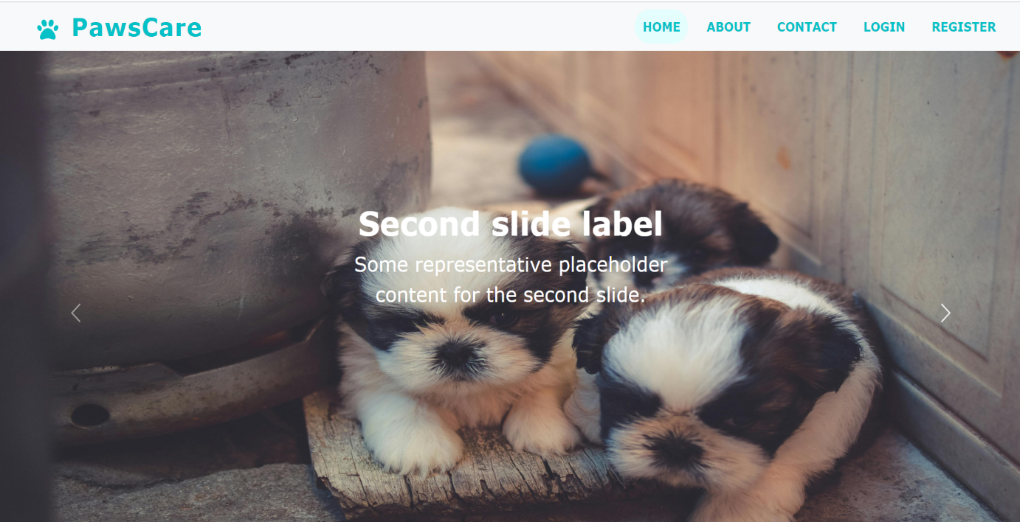

Figure 9.1 Home Page

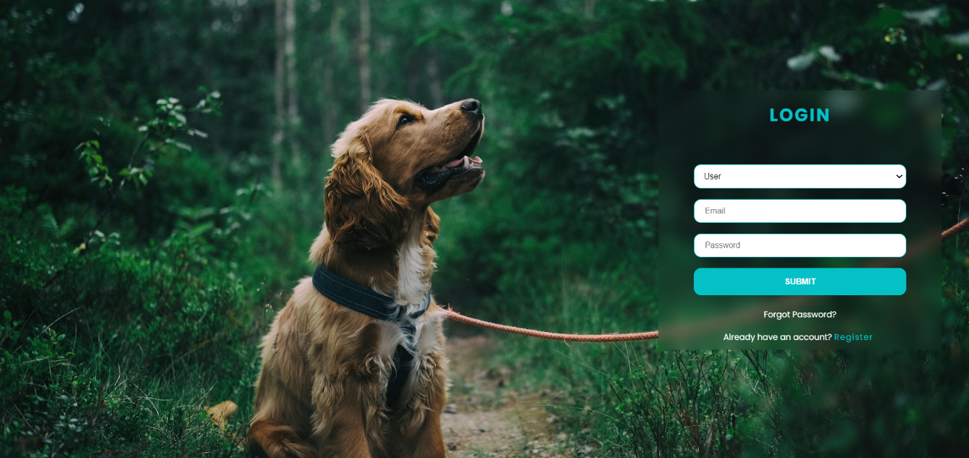

Figure 9.2 User login Page

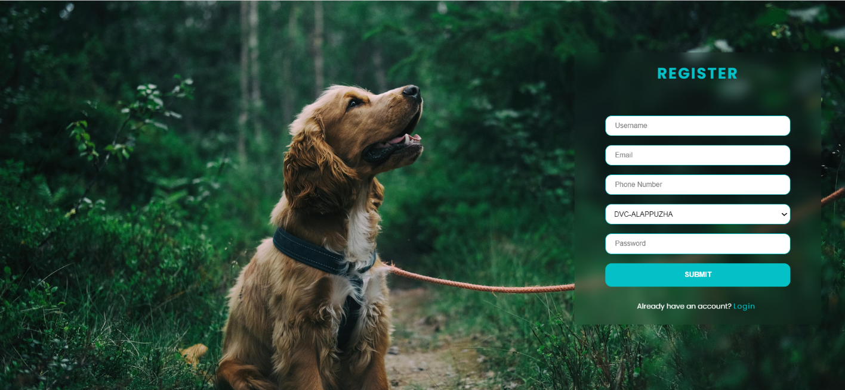

Figure 9.3 New User register Page

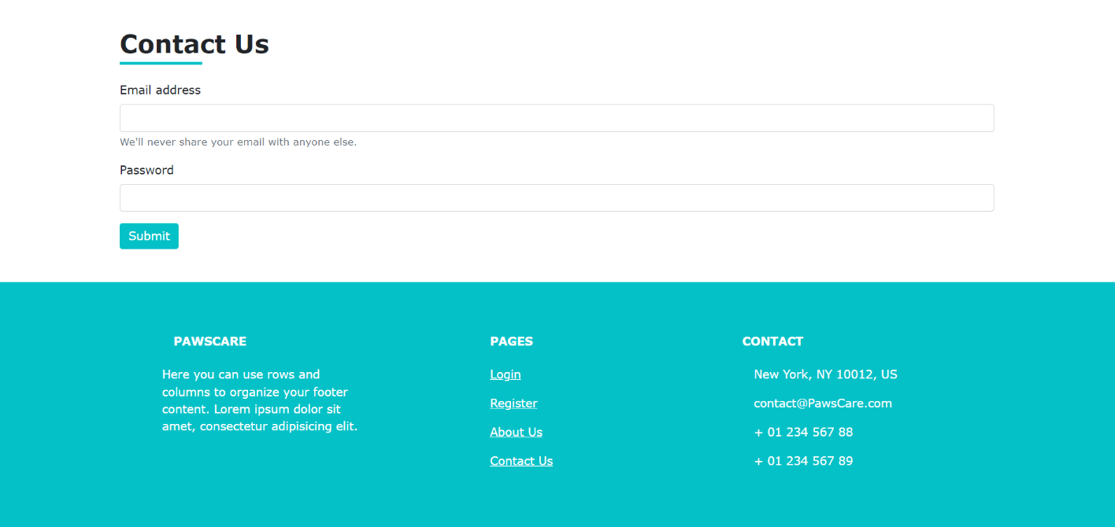

Figure 9.4 Contact Info Page

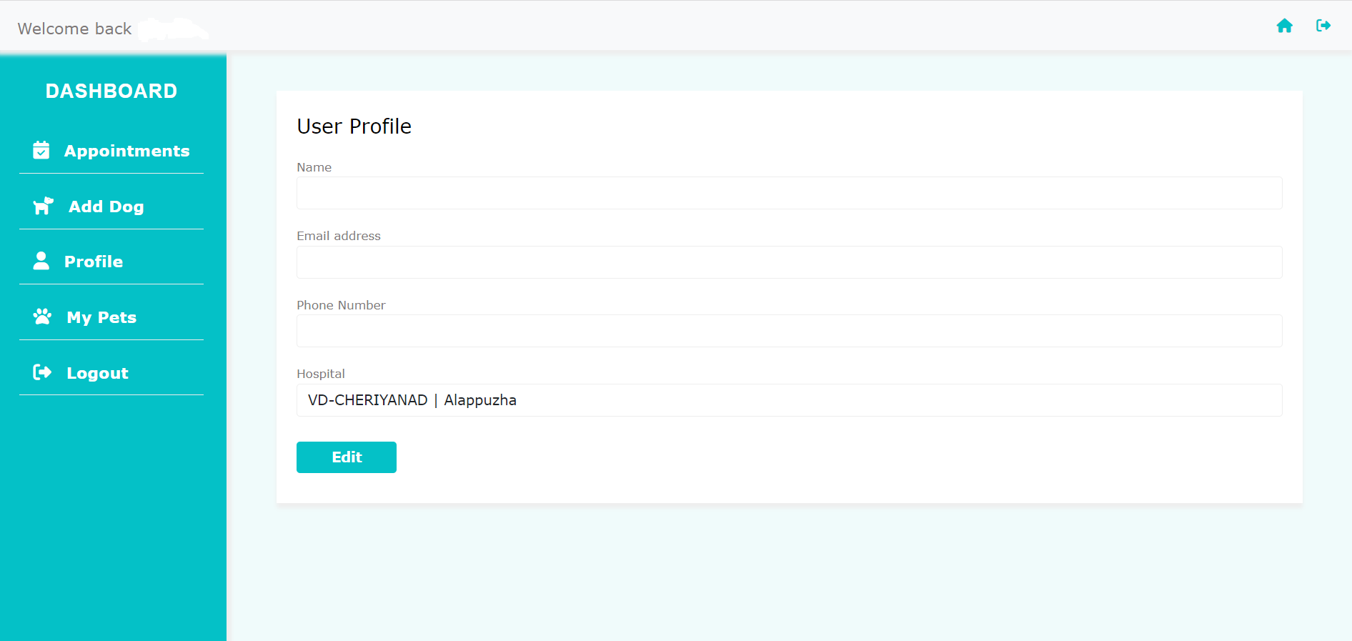

Figure 9.5 User Dash Board

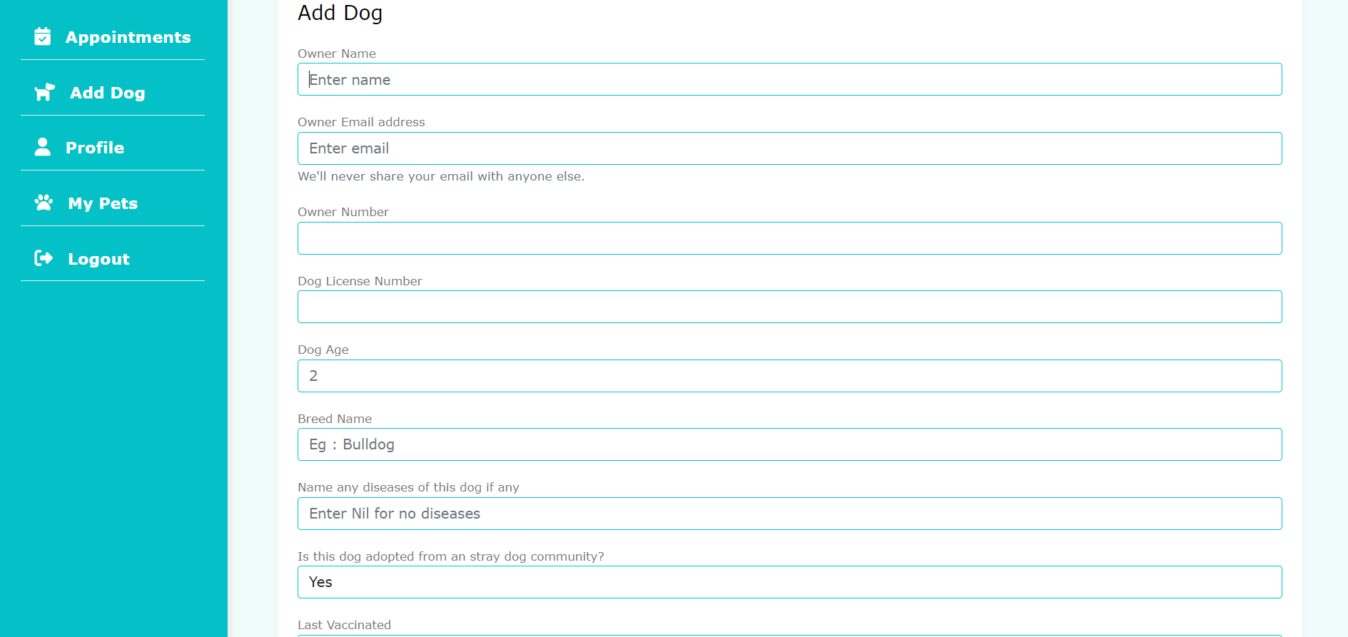

Figure 9.6 Adding Details

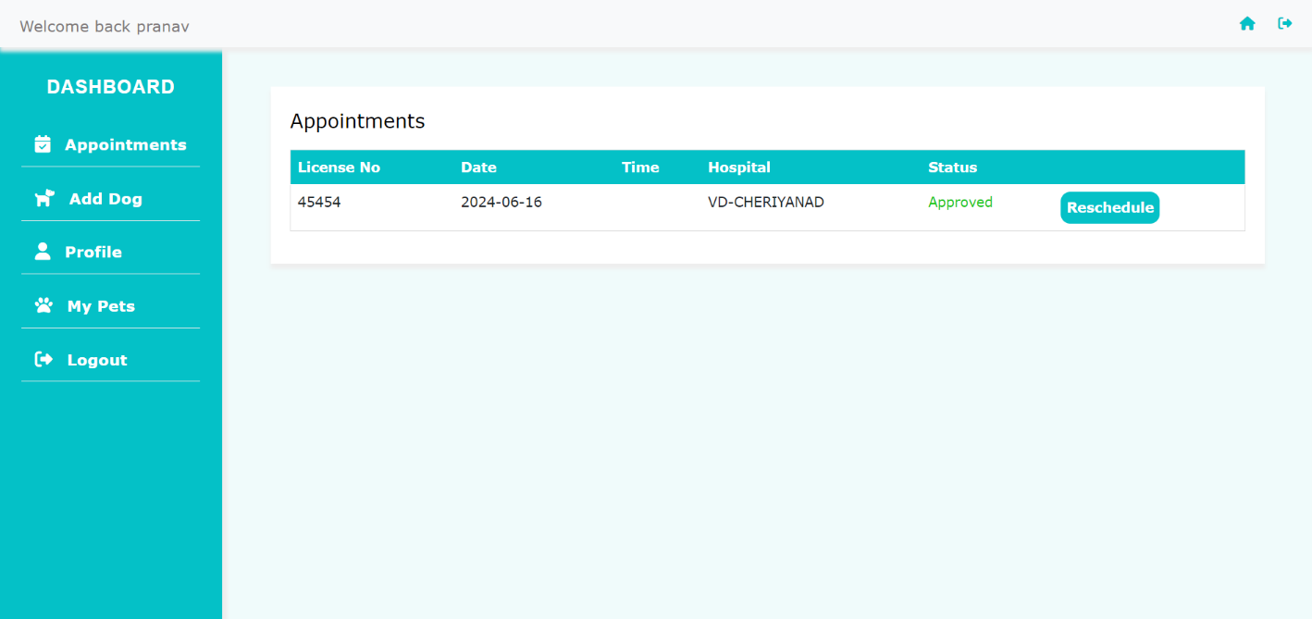

Figure 9.7 User Appointment Details

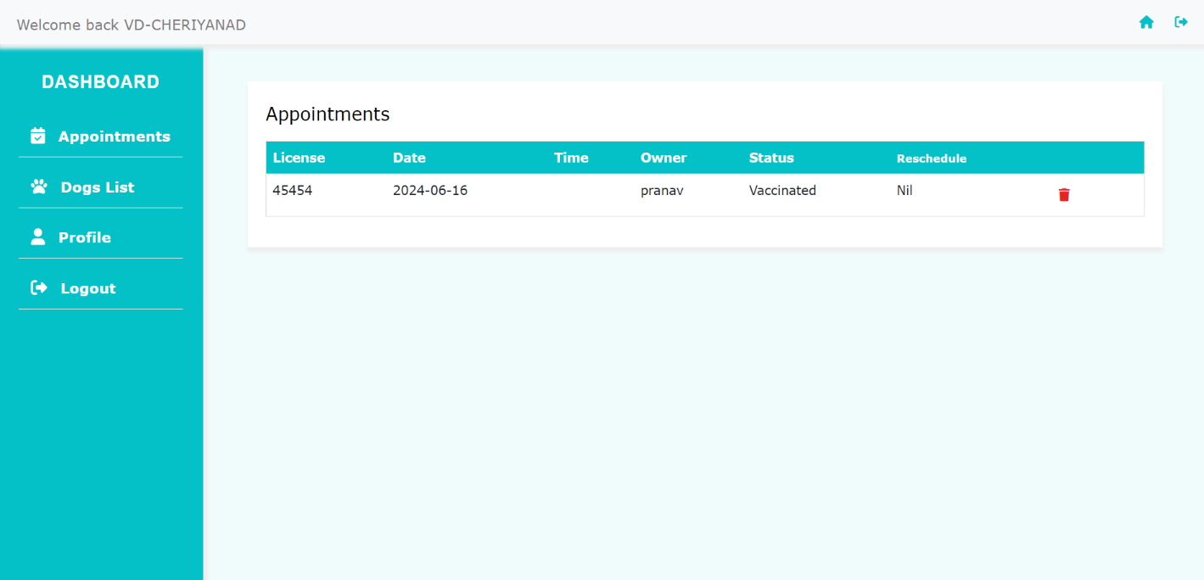

Figure 9.8 Hospital Dashboard

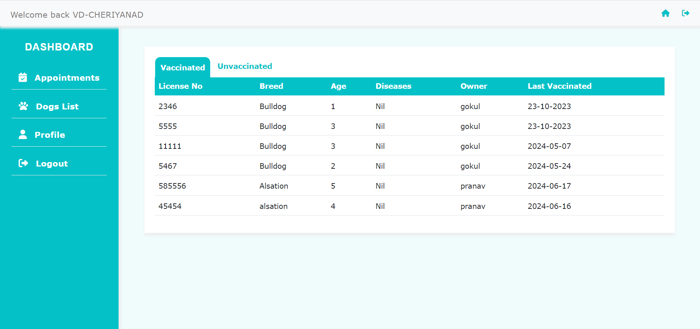

Figure 9.9

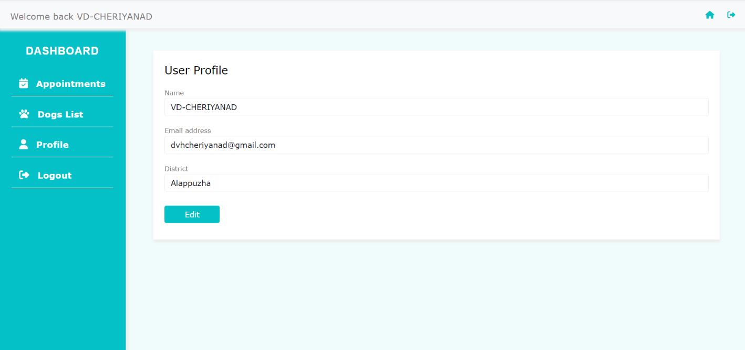

Figure 9.10 Hospital Details

